INFOSYS SPRINGBOARD VIRTUAL INTERNSHIP
MODULE-3
GUEST ANALYSIS MODULE
NAME: N.Rachana
PROJECT NAME: HotelRevAI AI Driven Revenue Analysis for Hotels_Batch -13

Step-1 : Creation of TblGuests Table
A table named TblGuests was created in Power BI and three columns were added: RecencyScore, FrequencyScore, and SpendScore.
TBI_Guests =
SUMMARIZE(
'TBI_Bookings',
'TBI_Bookings'[CustomerID],
"FirstStay",MIN('TBI_Bookings'[CheckInDate]),
"LastStay",MAX('TBI_Bookings'[CheckOutDate])
)
These columns are based on RFM analysis:
- RecencyScore – shows how recently a guest made a booking
RecencyScore =
DATEDIFF(
CALCULATE(
MAX('TBI_Bookings'[CheckOutDate]),
FILTER('TBI_Bookings','TBI_Bookings'[CustomerID] = 'TBI_Guests'[CustomerID])
),
TODAY(),DAY
)

- FrequencyScore – shows how often a guest makes bookings
FrequencyScore =
CALCULATE(
COUNTROWS('TBI_Bookings'),
FILTER('TBI_Bookings','TBI_Bookings'[CustomerID] = 'TBI_Guests'[CustomerID])
)
- SpendScore – shows how much a guest spends
SpendScore =
CALCULATE(
SUM(TBI_Bookings[DayRevenue]),
FILTER('TBI_Bookings','TBI_Bookings'[CustomerID] = 'TBI_Guests'[CustomerID])
)
These scores help in identifying customer behavior and segmenting guests for better analysis and decision-making.
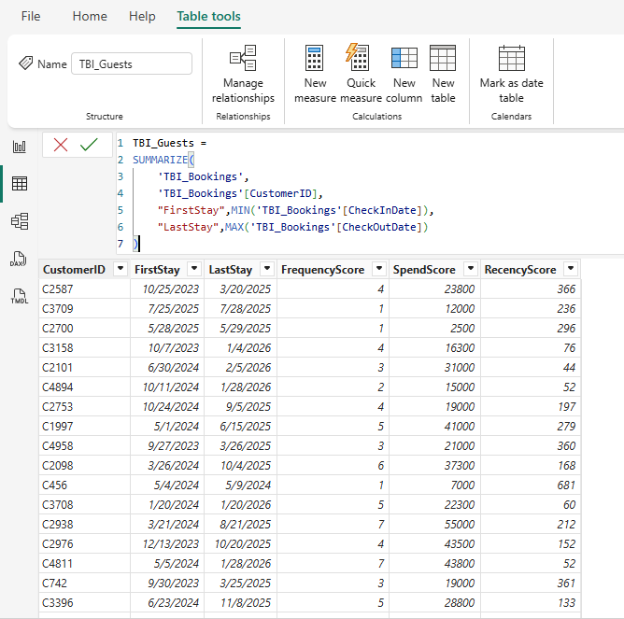

Step-2: Updating Bookings Table with Additional Columns
In Power BI, the data was refreshed and the remaining dataset was loaded successfully. After that, additional columns were added to the existing Bookings table:
- SourceType
SourceType =
SWITCH(
TRUE(),
Booking[BookingChannel] = "Website", "Direct",
Booking[BookingChannel] = "Mobile App", "Direct",
Booking[BookingChannel] = "Call Center", "Direct",
Booking[BookingChannel] = "Travel Agent", "Agent",
"Other"
)
- GuestType
GuestType =
SWITCH(TRUE(),
[purpose] = "Business" || [BookingChannel] = "Corporate", "Business",
[purpose] = "Vacation" && [Stay Type] = "Extended Stay", "Family",
[purpose] = "Holiday" && [Stay Type] = "Extended Stay", "Family",
[purpose] = "Conference" || [Stay Type] = "Extended Stay", "Corporate","Solo"
)
- RoomRate
RoomRate = RELATED(RoomType[Price])
- NumOfBookings
NumOfBookings =
CALCULATE(
COUNT(Booking[BookingID]),
ALLEXCEPT(Booking,Booking[CustomerID])
)
- CustomerCluster
CustomerCluster =
SWITCH(TRUE(),
[NumOfBookings]=1 && [Revenue]<5000,"First-Timer",
[NumOfBookings]>=3 && [Revenue]<15000,"Loyal Guest",
[Revenue]>= 15000,"High Spender","Other")

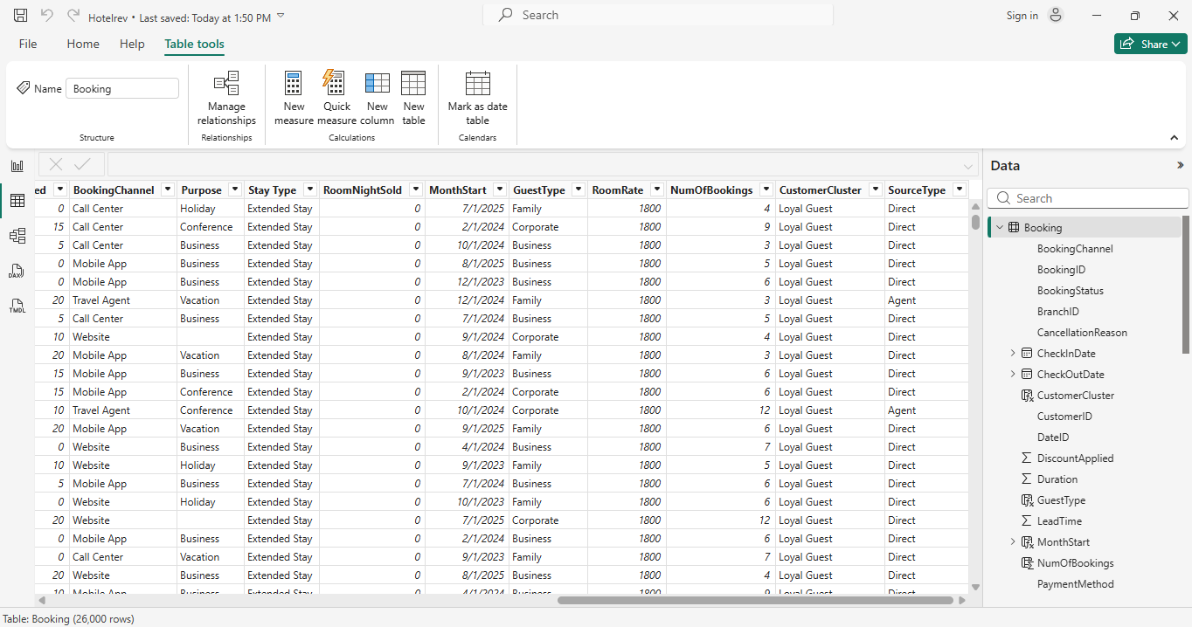

Step-3: Visualization Steps in Power BI
Step 1: Stacked Column Chart (Nationality vs Booking Count)
- Open Power BI
- Choose Stacked Column Chart
- Add Nationality to X-axis
- Add Guest Type to Legend
- Add BookingID to Values and set it to Count
Step 2: Clustered Column Chart (Booking Channel vs Guest Type)
- Select Clustered Column Chart
- Place Booking Channel on X-axis
- Place Guest Type in Legend
- Add BookingID to Values → set as Count
Step 3: Column Chart (Average Duration by Guest Type)
- Choose Column Chart
- Drag Guest Type to X-axis
- Drag Duration to Values → set as Average
Step 4: Pie Chart (Booking Status)
- Select Pie Chart
- Add Booking Status to Legend
- Add BookingID to Values → set as Count
Step 5: Pie Chart (Payment Method – Booking Count)
- Choose Pie Chart
- Drag Payment Method to Legend
- Drag BookingID to Values → set as Count
Step 6: Pie Chart (Payment Method – Revenue)
- Select Pie Chart
- Add Payment Method to Legend
- Add Revenue to Values → set as Sum
Step 7: Applying Filter (Gender)
- Insert a Slicer visual
- Add Gender field to slicer
- Select required options: Male, Female, Others
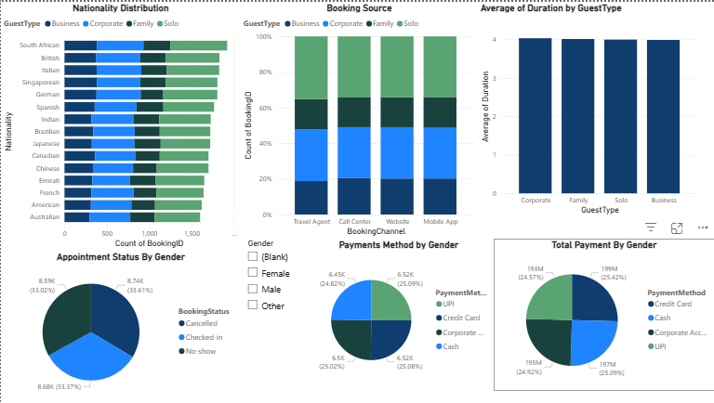

Step-4: Customer Analysis Visualizations
Scatter Plot Creation (Customer Analysis)
Step 1: Select Scatter Chart
- Open Power BI and switch to Report View
- Choose Scatter Chart from Visualizations pane
Step 2: Add Required Fields
- Place RecencyScore on X-axis
- Place FrequencyScore on Y-axis
- Place SpendScore in Size
Step 3: Set Aggregation
- Set SpendScore as Count
- Set FrequencyScore as Sum
Step 4: Add Legend
- Drag CustomerCluster into Legend
Step 5: Apply Filters (Slicers)
- Insert Slicer and add GuestType
- Insert another Slicer and add CustomerCluster
- Insert one more Slicer and add SourceType
- Select values to filter the scatter plot
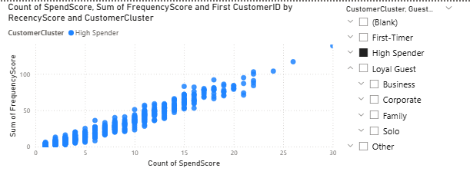

Step-5: Map Visualization (Nationality vs Customer Cluster)
Step 1: Create Map
- Select Map Visual in Report View
- Add Nationality to Location
- Add CustomerCluster to Legend
- Add CustomerID to Size → set as Count
Stacked Column Chart (Customer Count Analysis)
Step 1: Create Chart
- Select Stacked Column Chart
- Add GuestType to X-axis
- Add SourceType to Legend
- Add CustomerID to Values → set as Count
Apply Slicer (Customer Cluster)
Step 1: Add Filter
- Insert Slicer visual
- Drag CustomerCluster into slicer
- Choose required values to filter all visuals
